**Algorithm Team Project Brief**

**RedBack Operations**

**Team Members**

* **Shashvat Joshi (Team Leader)**
* **William Hebblewhite**
* **Andrew Mayes**
* **Hyun (Chris) Dong Kim - (GAM/ERG Team Lead)**
* **Jack Fleming**

**Projects Undertaken/Completed**

Our team have worked through multiple projects throughout our Endeavor and have produced sufficient results keeping inclined with our Company RedBack Operations End Goal of creating Open Exercise Community empowered by people. For our First Project, we worked on **Time Regression Series** with goal of producing algorithm to predict performance of a user in any simulated course based on the characteristics of user and said simulated course. Hypothesis for this algorithm was developed centered around Lasso (Least absolute shrinkage & selection process), Hierarchical Representation using NMF and Future-based Representation.

Second Project we worked upon the model creation of **O2 Predictor model among riders** utilizing pulmonary VO(2) rise in muscle in an exponential fashion after the onset of exercise in cycling. Aim of this study is to provide research documentation & prototype model to predict the O2 Uptake in cyclist & provide reliable health performance indicators and feedbacks to user. Three models were created NN-MLPRefressor Model, Linear Regression Model & Decesion Tree model and were evaluated/ optimized for their performance which at end produced desired predicted results. An O2 Uptake Research Theory document was also developed to be utilized by future students in understanding this Research

Third project our team worked on is predicting oxygen consumption across various forms of exercise and timeframes with deep learning methods. The interest in doing so was to identify easily obtainable inputs to predict VO2, which typically requires sophisticated and sanitised measuring instruments. The project to date is reasonably successful refer to results down below. In addition, supplementary material in the form of a report has been created in order for future collaborators to develop an understanding of the necessary knowledge as quickly and easily as possible.

<Fourth Hyun (Chirs) PART> GAM Research – Fourth Proj

Our team also worked on our Sprint Research with two tasks provided to us. First being Researching ML algorithms to improve efficiency in **Incentives Problem** & second **Fuzziness** in relation to Algorithms and Game System. This research to be inclined with an joint effort with the games being developed by our in house Web -App And Game development team.

**Evidence/Screenshot Section**

1. **O2 Uptake Prediction Model**

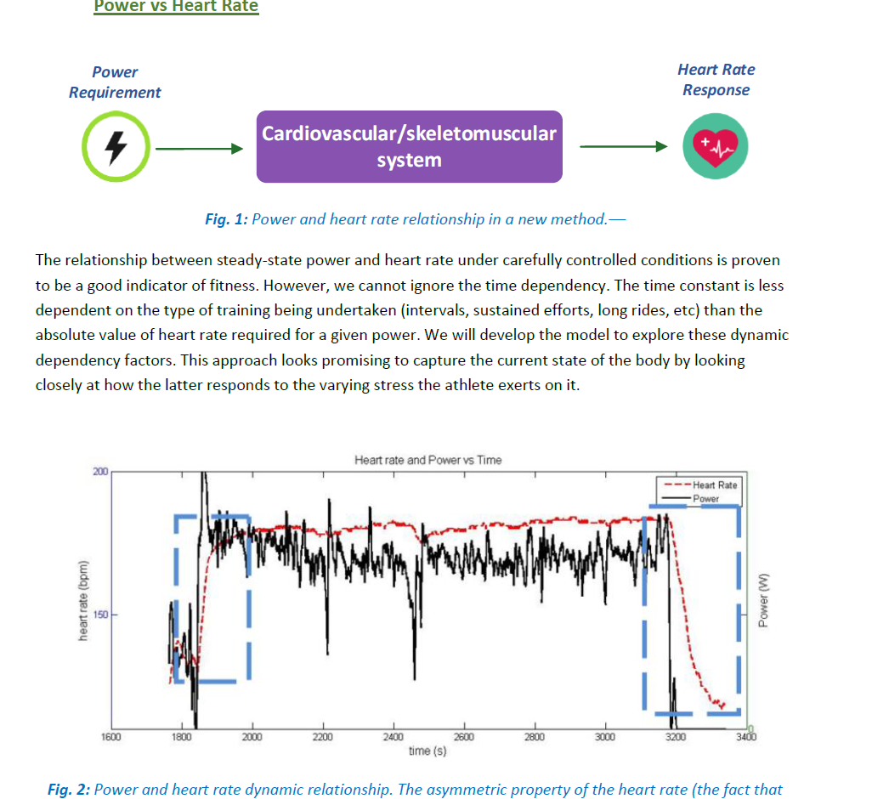

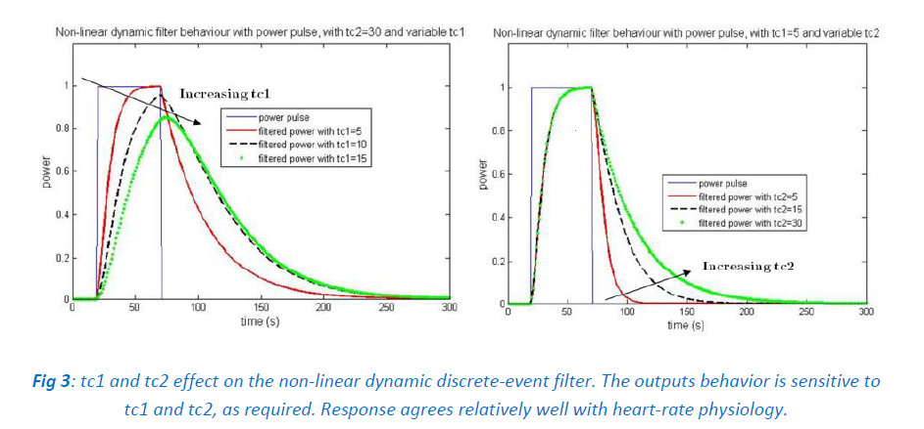

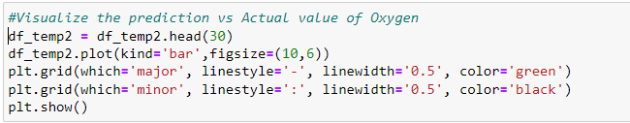

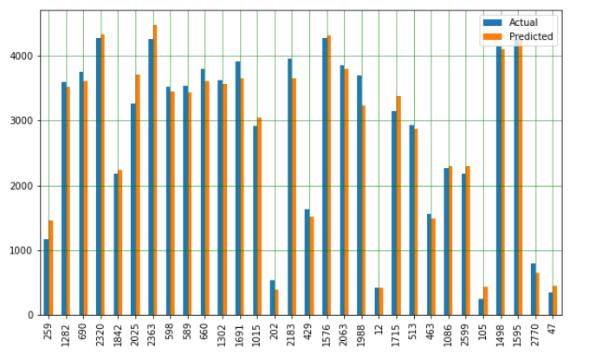

***Fig****: Visual Representation of*

*Predicted vs. Actual Value of Oxygen*

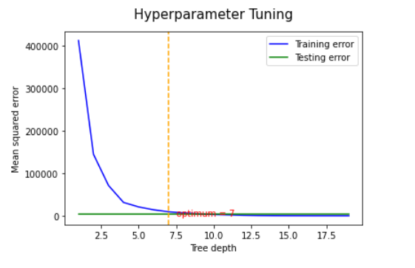

***Fig****: Hyper parameter tuning for decision tree regression*

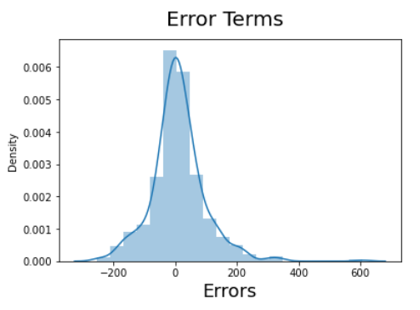

***Fig****: Error distribution almost gaussian in nature*

1. **LSTM Research**

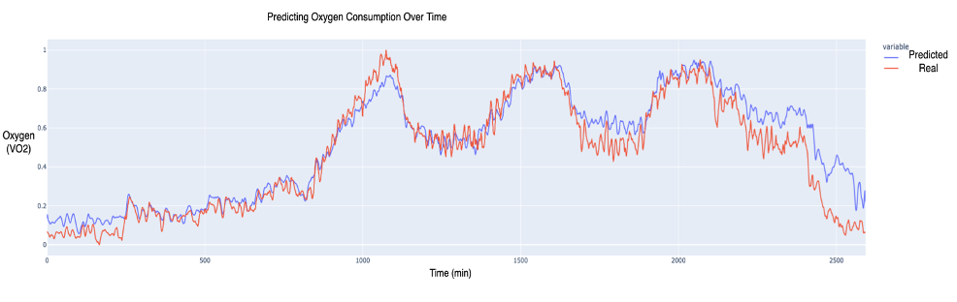

1. **GAM Research**

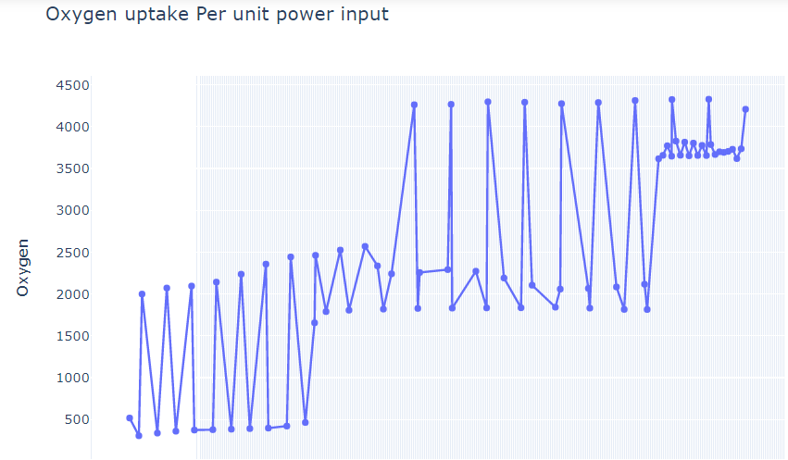

***Fig****: Oxygen uptake Per unit input power*

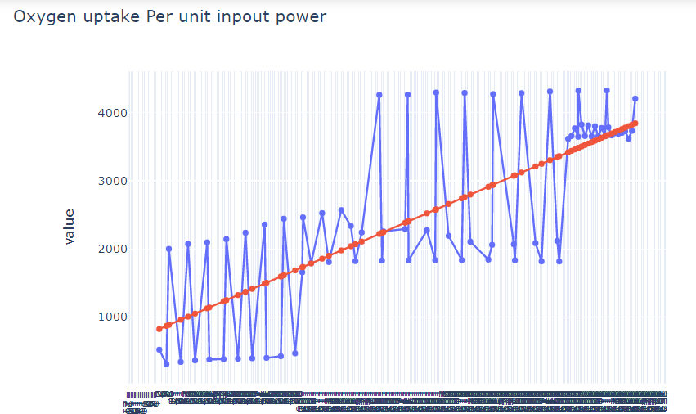

***Fig****: Linear regression take on Oxygen uptake Per unit input power*

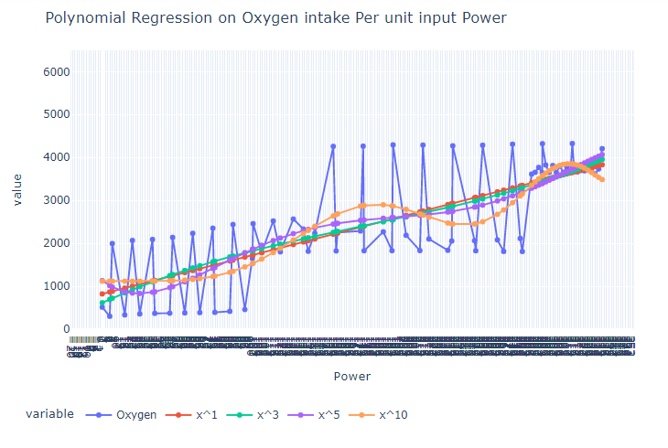

***Fig****: Polynomial Regression on Oxygen uptake Per unit input power*

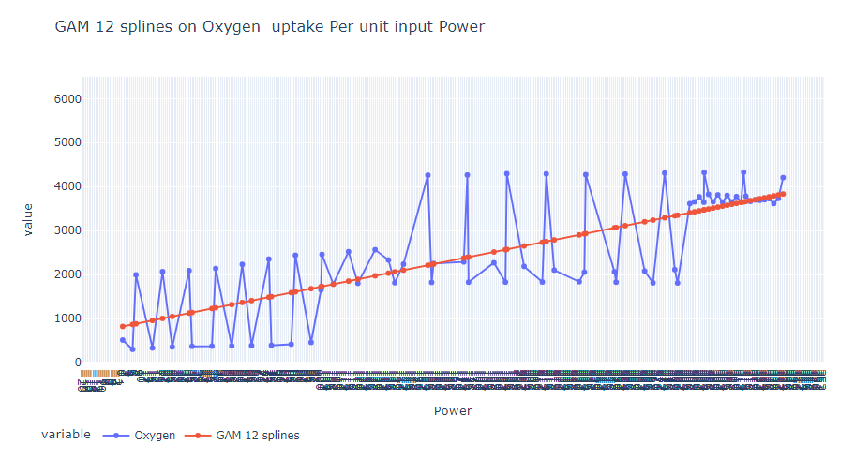

***Fig****: GAM 12 Splines on Oxygen uptake Per unit input power*

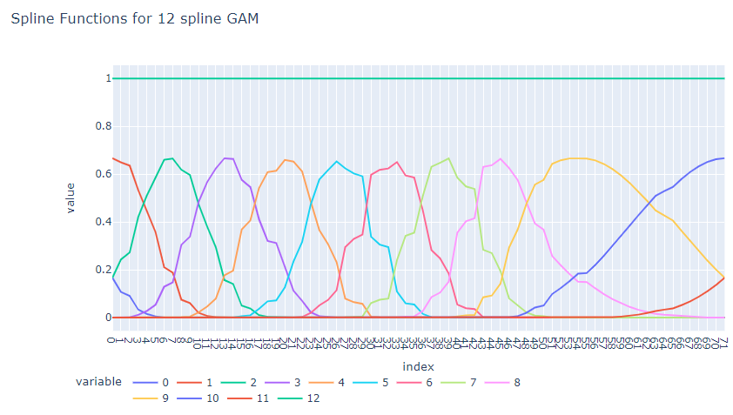

***Fig****: Spline Functions for 12 spline GAM*

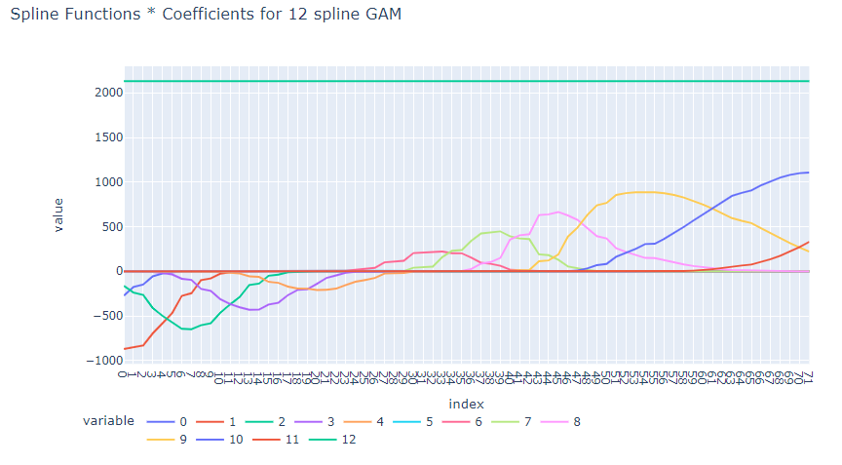

***Fig****: Spline Functions * Coefficients for 12 spline GAM*

1. **Incentives Problems**

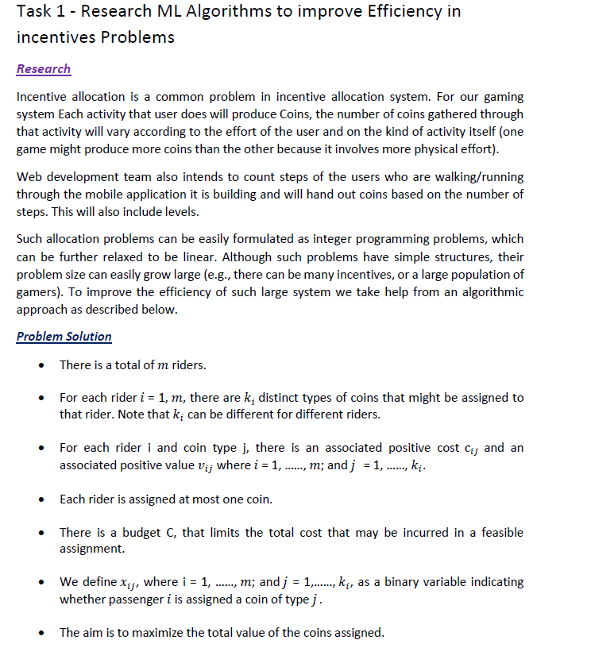

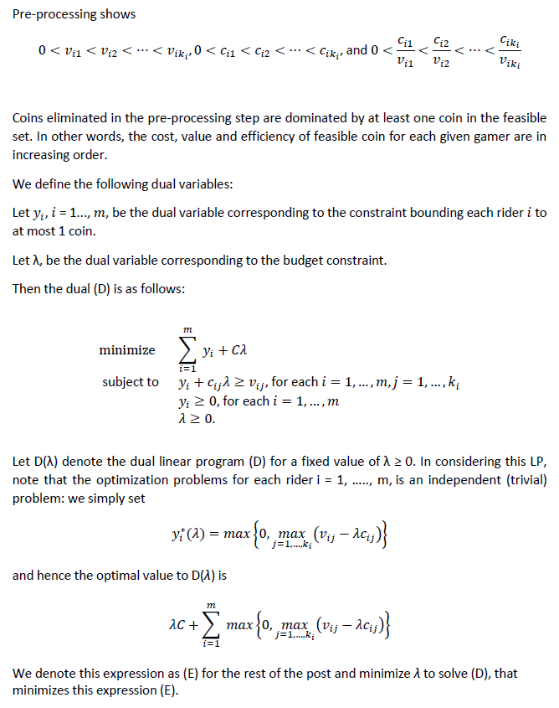

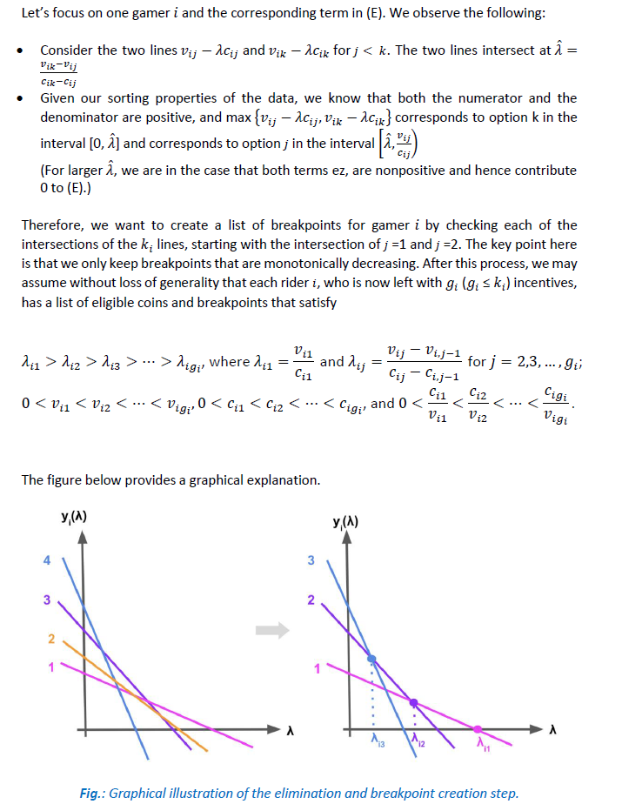

1. **Fuzziness in Algorithm & Games**

